Ansible-04 tasks
- Create ansible playbook to create ansible vault.
1. Create an Ansible Vault
Objective: Store sensitive information, such as passwords, securely using Ansible Vault.
Step 1: Create a project directory
mkdir vault-lab
cd vault-lab 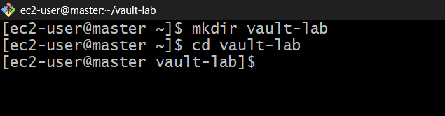
Step 2: Create an encrypted variables file
ansible-vault create secrets.yml
Enter and confirm a vault password. An editor opens; add:
db_username: admin
db_password: devops@123
Save and exit the editor.
Step 3: Verify the encrypted file
cat secrets.yml
You should see an Ansible Vault header and encrypted content, not your readable variables. 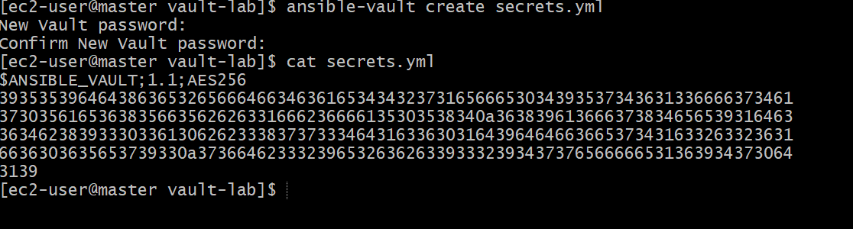

Step 4: Create a playbook
Create vault-playbook.yml:
---
- name: Read encrypted variables
hosts: localhost
connection: local
gather_facts: false

vars_files:
- secrets.yml

tasks:
- name: Display database username
ansible.builtin.debug:
msg: "Database user is {{ db_username }}"
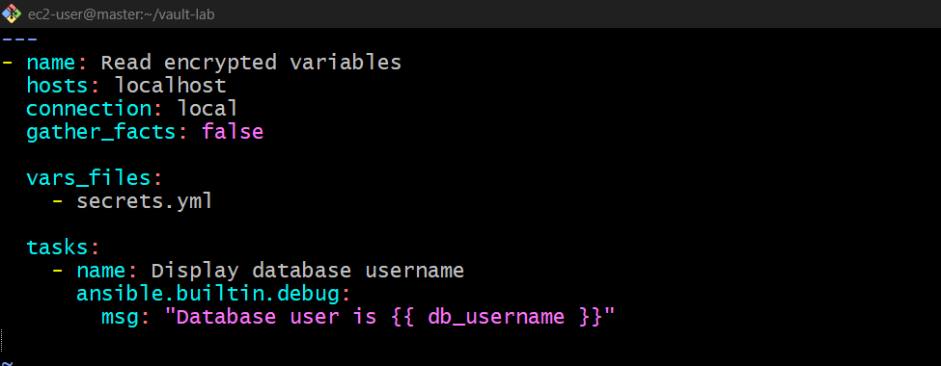
Step 5: Run the playbook
ansible-playbook vault-playbook.yml --ask-vault-pass
Enter your vault password when prompted.
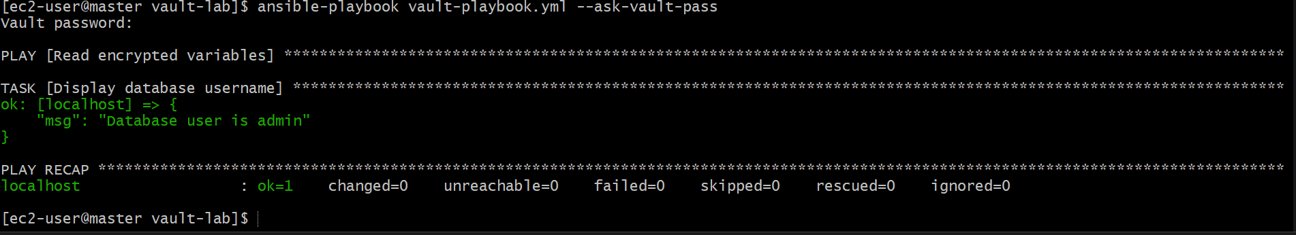
Command | Purpose
ansible-vault create secrets.yml | Create an encrypted file
ansible-vault edit secrets.yml | Edit encrypted variables
ansible-vault view secrets.yml | View decrypted contents in the terminal
ansible-vault encrypt vars.yml | Encrypt an existing file
ansible-vault decrypt secrets.yml | Decrypt a file permanently
ansible-vault rekey secrets.yml | Change the vault password
Useful Vault commands:
Interview point: Ansible Vault encrypts sensitive data at rest. It does not automatically encrypt every file in your project.

- Write an ansible playbook to install Apache in Linux and ubuntu machine by using when condition.
Objective: Use Ansible facts and a when condition to install Apache using the correct package name on each operating system.
Step 1: Create the project
mkdir apache-when-lab
cd apache-when-lab
vi inventory
Create an inventory file:
[webservers]
amazon ansible_host=172.31.17.9
ubuntu ansible_host=172.31.28.206

[webservers:vars]
ansible_user=ec2-user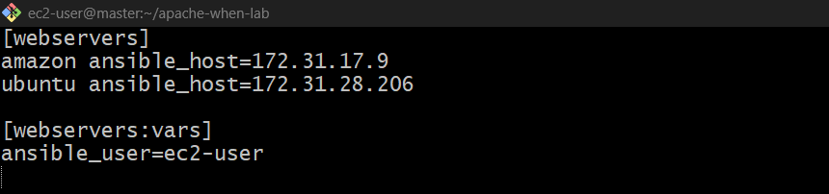
These are example private IPs. Replace them with your actual worker IPs. If your Ubuntu host uses a different SSH user, configure it separately.
Step 2: Create apache.yml
---
- name: Install Apache on different Linux systems
hosts: webservers
become: true
gather_facts: true

tasks:
- name: Install Apache on Amazon Linux
ansible.builtin.dnf:
name: httpd
state: present
when: ansible_facts['distribution'] == "Amazon"

- name: Install Apache on Ubuntu
ansible.builtin.apt:
name: apache2
state: present
update_cache: true
when: ansible_facts['distribution'] == "Ubuntu"

- name: Start Apache on Amazon Linux
ansible.builtin.service:
name: httpd
state: started
enabled: true
when: ansible_facts['distribution'] == "Amazon"

- name: Start Apache on Ubuntu
ansible.builtin.service:
name: apache2
state: started
enabled: true
when: ansible_facts['distribution'] == "Ubuntu"
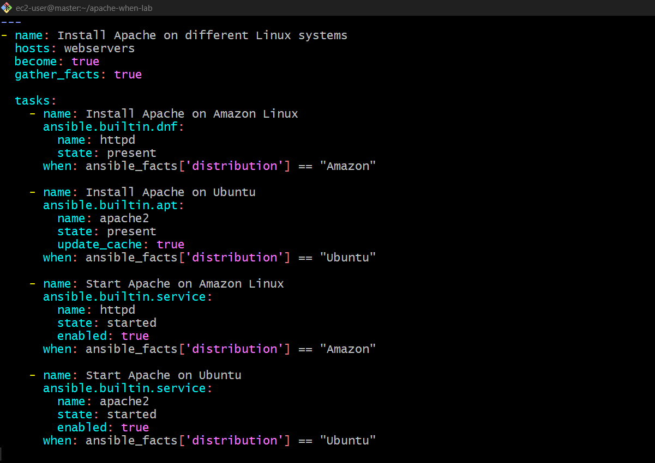

Step 3: Execute the playbook
ansible-playbook -i inventory apache.yml 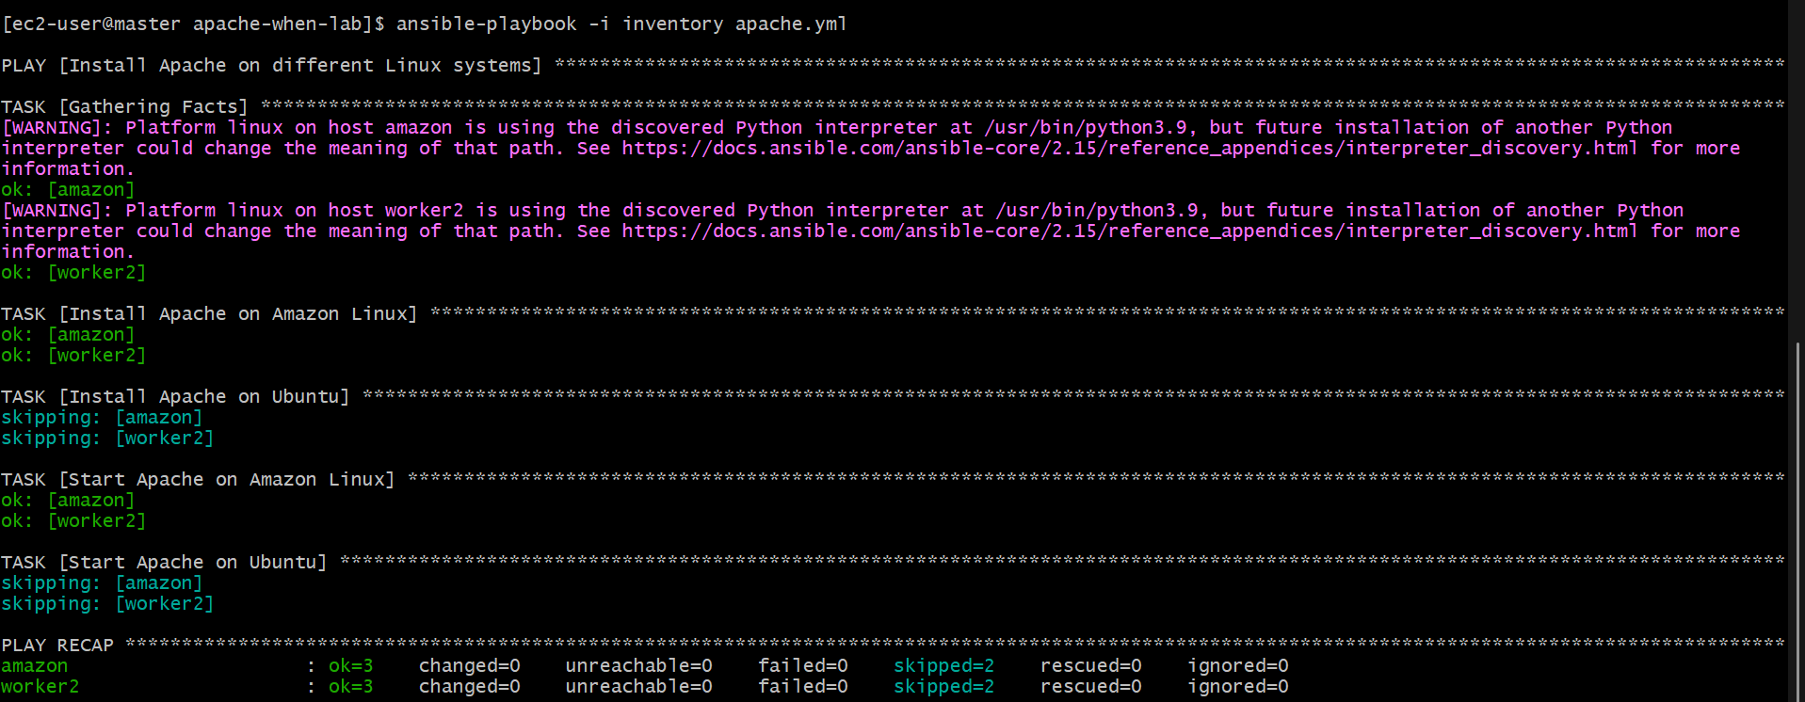
If your sudo configuration requires a password:
ansible-playbook -i inventory apache.yml -K
How the when condition works
- Amazon Linux: installs httpd using dnf and starts the httpd service.
- Ubuntu: installs apache2 using apt and starts the apache2 service.
- Ansible skips the tasks whose conditions do not match.
Check the service on each machine:
# Amazon Linux
sudo systemctl status httpd

# Ubuntu
sudo systemctl status apache2
Note: ansible_facts['distribution'] is populated when fact gathering is enabled. The example assumes Amazon Linux and Ubuntu targets; other distributions will skip both sets of tasks.

- Create ansible playbook using roles to configure LAMP stack
Step 1: Create the project directory
Run these commands on your Ansible master:
mkdir -p ~/lamp-role-lab
cd ~/lamp-role-lab
Copy your working inventory from the previous lab:
cp ~/apache-when-lab/inventory . 
Check it:
cat inventory
It should contain both workers under [webservers], with the correct IPs, SSH usernames, and key path.
Step 2: Create the Ansible roles
Run:
ansible-galaxy init roles/apache
ansible-galaxy init roles/mariadb
ansible-galaxy init roles/php
If a role already exists, you can keep it; don't initialize it again.
The structure will be:
lamp-role-lab/
├── inventory
├── lamp.yml
└── roles/
├── apache/tasks/main.yml
├── mariadb/tasks/main.yml
└── php/tasks/main.yml
Step 3: Create the Apache role
Open the file:
vi roles/apache/tasks/main.yml
Press i and paste:
---
- name: Install Apache
ansible.builtin.dnf:
name: httpd
state: present

- name: Start and enable Apache
ansible.builtin.service:
name: httpd
state: started
enabled: true
Save and exit: press Esc, type :wq, then press Enter. 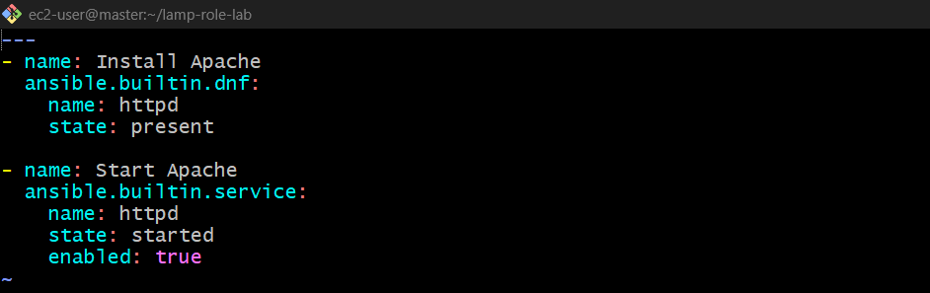
Step 4: Create the MariaDB role
Open:
vi roles/mariadb/tasks/main.yml
Press i and paste:
---
- name: Install MariaDB server
ansible.builtin.dnf:
name: mariadb105-server
state: present

- name: Start and enable MariaDB
ansible.builtin.service:
name: mariadb
state: started
enabled: true
Save and exit with Esc, :wq, Enter. 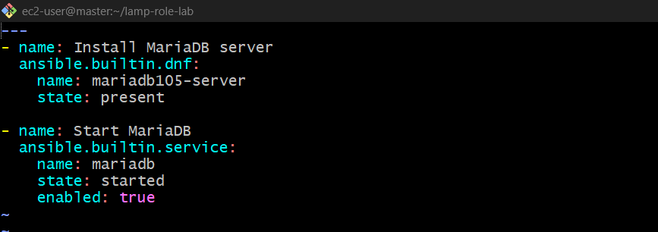
Step 5: Create the PHP role
Open:
vi roles/php/tasks/main.yml
Press i and paste:
---
- name: Install PHP packages
ansible.builtin.dnf:
name:
- php
- php-mysqlnd
state: present

- name: Create PHP test page
ansible.builtin.copy:
dest: /var/www/html/index.php
content: '<?php echo "LAMP Stack is working!"; ?>'
owner: apache
group: apache
mode: '0644'

- name: Restart Apache
ansible.builtin.service:
name: httpd
state: restarted
Save and exit. 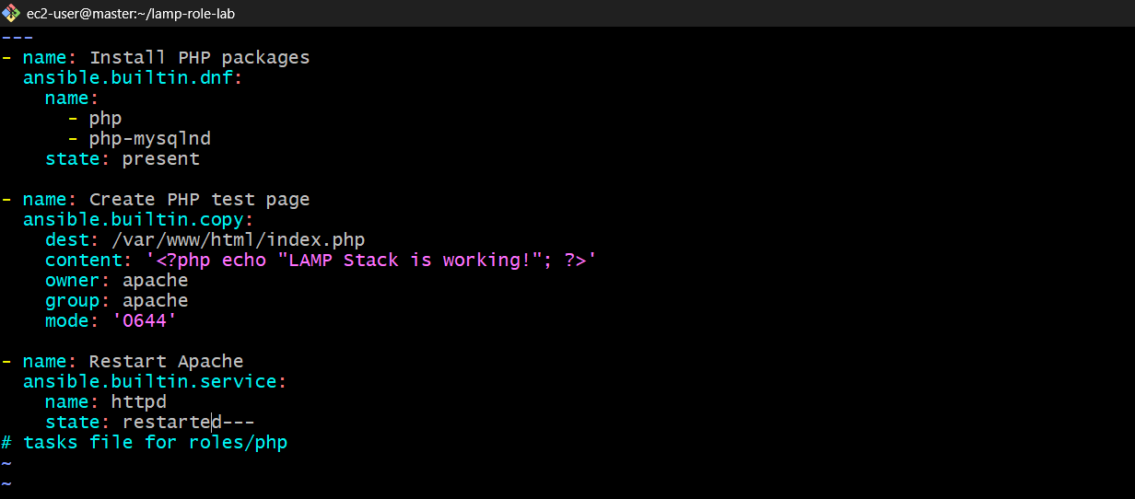
Step 6: Create the main playbook
Open:
vi lamp.yml
Paste:
---
- name: Configure LAMP Stack using roles
hosts: webservers
become: true

roles:
- apache
- mariadb
- php
Save and exit. 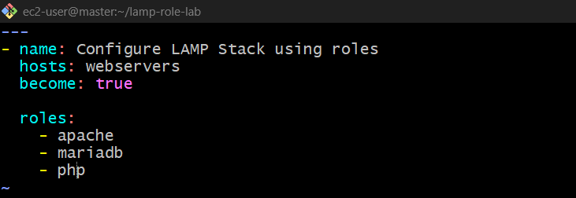
Step 7: Verify your files
Run:
cat lamp.yml
cat roles/apache/tasks/main.yml
cat roles/mariadb/tasks/main.yml
cat roles/php/tasks/main.yml
Step 8: Test the worker connections
ansible all -i inventory -m ping
Both workers should return pong. 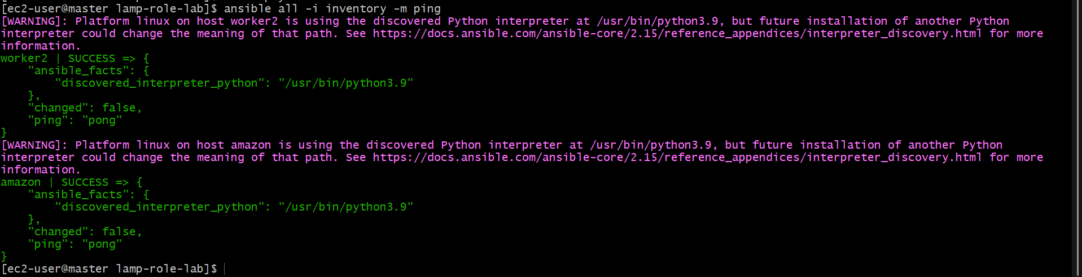
Step 9: Run the LAMP playbook
ansible-playbook -i inventory lamp.yml
Ansible will execute the roles in order: Apache, MariaDB, then PHP. 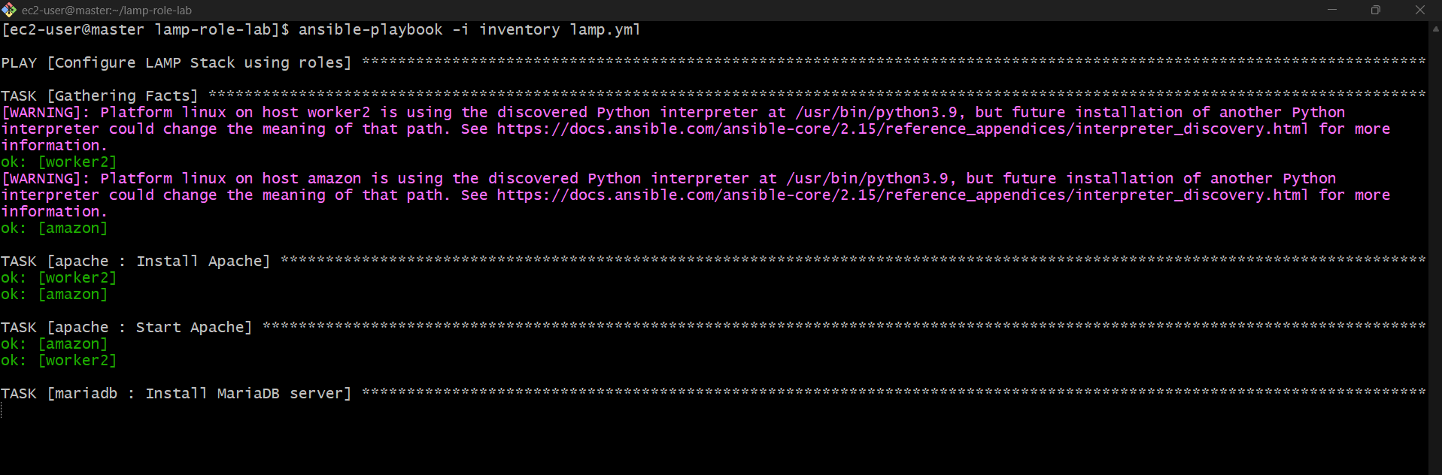
Step 10: Verify the installation
Check Apache:
ansible all -i inventory -b -m command -a "systemctl is-active httpd" 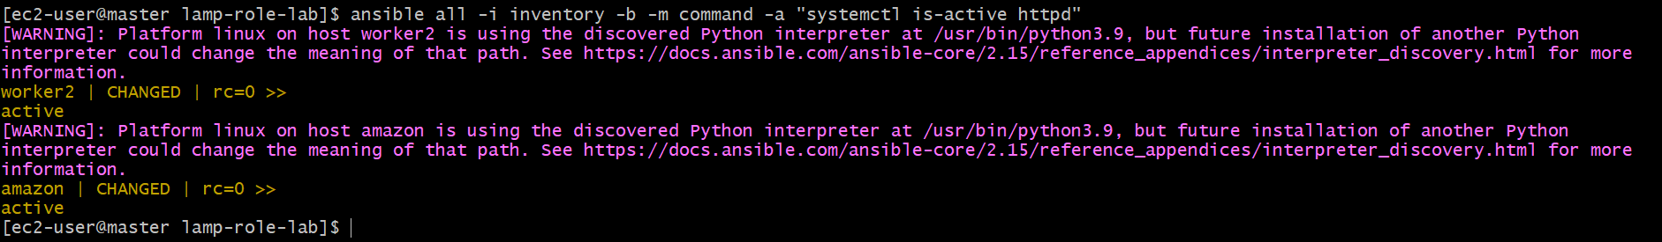
Check MariaDB:
ansible all -i inventory -b -m command -a "systemctl is-active mariadb" 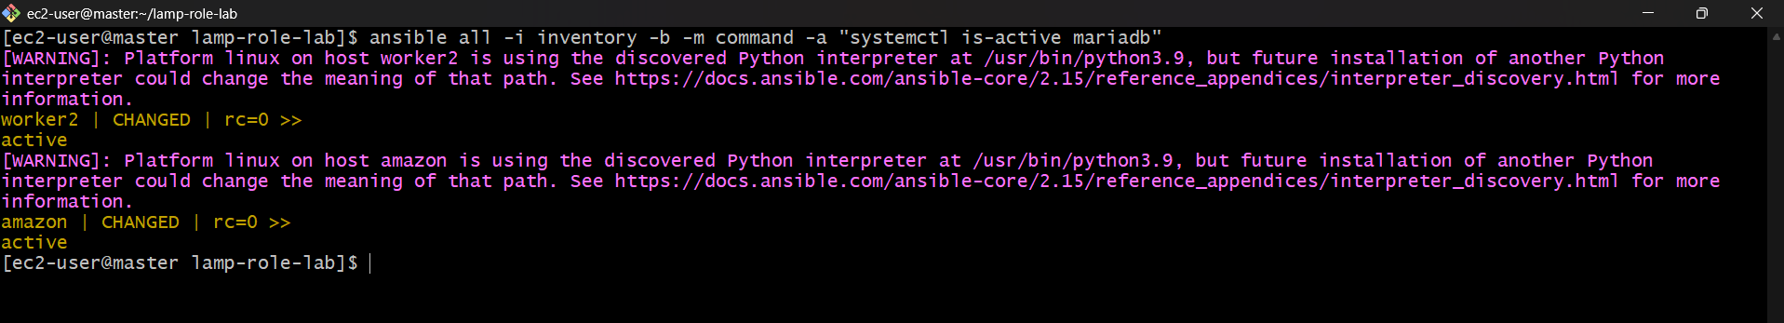
Check PHP:
ansible all -i inventory -b -m command -a "php -v"
Expected: Apache and MariaDB report active, and PHP prints its version. If a package installation fails, share the error before proceeding. 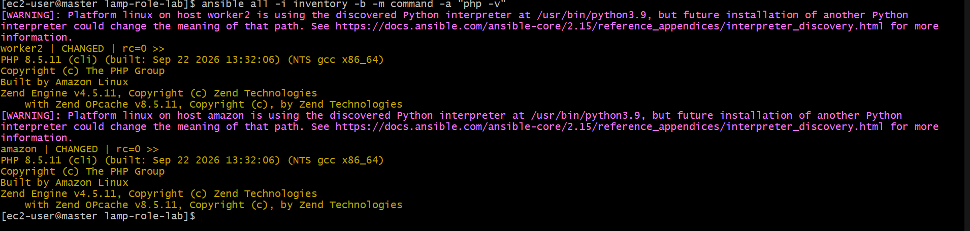

- Setup ansible AWX and explore the options.
Step 1: Check Kubernetes
Run on your Kubernetes control machine:
kubectl get nodes
Make sure the nodes are Ready. 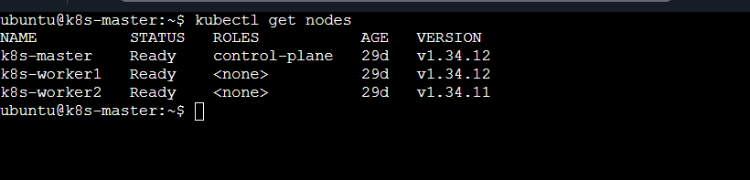
Step 2: Create the AWX namespace
kubectl create namespace awx

Step 3: Install the AWX Operator
1. Create a working directory
Run on your current k8s-master terminal:
mkdir -p ~/awx-setup
cd ~/awx-setup
2. Create the configuration file
Copy and paste this entire command:
cat > kustomization.yaml <<'EOF'
apiVersion: kustomize.config.k8s.io/v1beta1
kind: Kustomization
resources:
- github.com/ansible/awx-operator/config/default?ref=2.7.2
images:
- name: quay.io/ansible/awx-operator
newTag: 2.7.2
namespace: awx
EOF 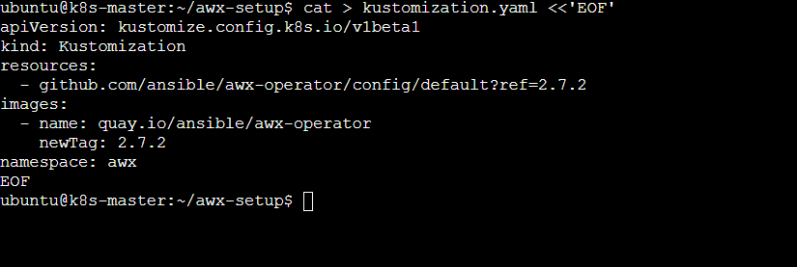
3. Install the operator
kubectl apply -k .
This command downloads the required Kubernetes configuration and creates the operator resources. 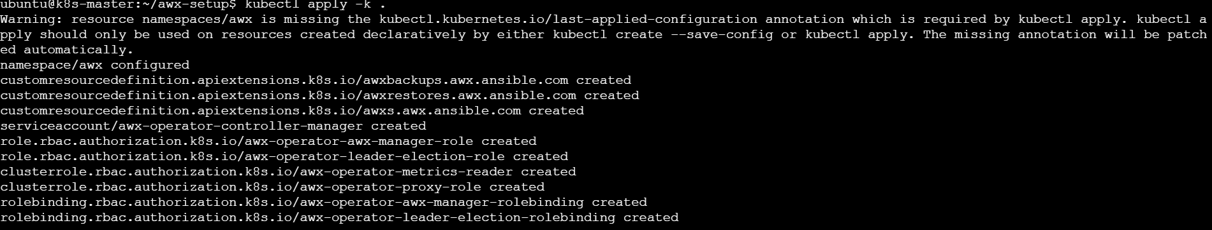
4. Check the installation
kubectl get pods -n awx
Step 4: Create the AWX configuration
Create a file:
vi awx.yaml
Use this basic AWX custom resource:
---
apiVersion: awx.ansible.com/v1beta1
kind: AWX
metadata:
name: awx
namespace: awx
spec:
service_type: NodePort
Save and exit (Esc, :wq, Enter). 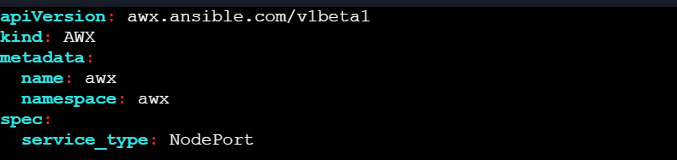

Apply it:
kubectl apply -f awx.yaml 
Step 5: Check the installation
kubectl get pods -n awx
Wait for the AWX application pods to become ready. You can also check:
kubectl get svc -n awx
Step 6: Get the administrator password
After AWX is deployed, run:
kubectl get secret -n awx 
Find the administrator password secret created by the operator. For the default resource name above, it is commonly awx-admin-password.
Retrieve it:
kubectl get secret awx-admin-password -n awx \
-o jsonpath='{.data.password}' | base64 --decode
echo
Step 7: Open AWX in your browser
Find the NodePort:
kubectl get svc -n awx 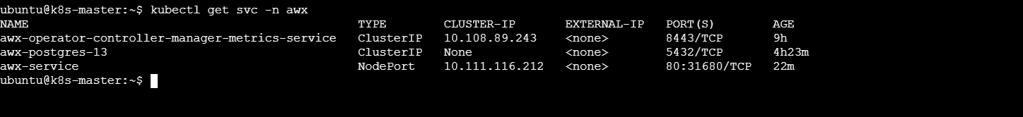
Open this address, replacing the placeholders with your node's reachable IP and the actual NodePort:
http://NODE-IP:NODEPORT
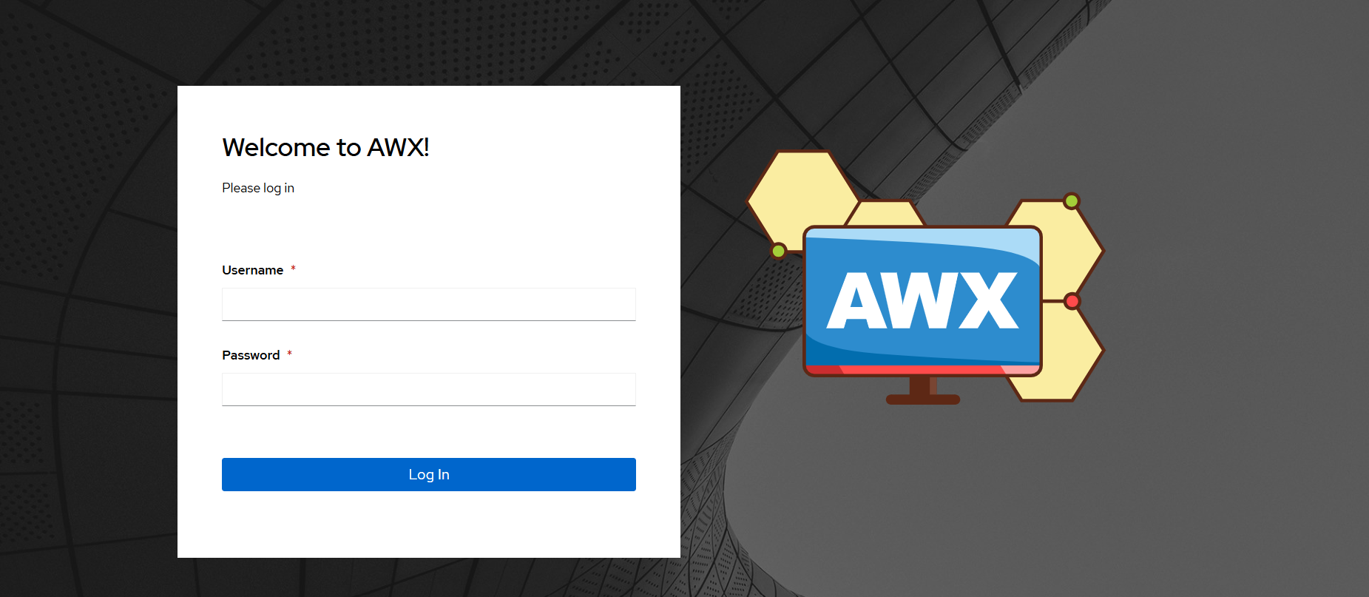
Log in with username admin and the password from Step 6. Ensure the relevant AWS security group allows access to that port from your IP.

Username:admin
Password: get password
kubectl get secret -n awx awx-admin-password \
-o jsonpath='{.data.password}' | base64 --decode
echo 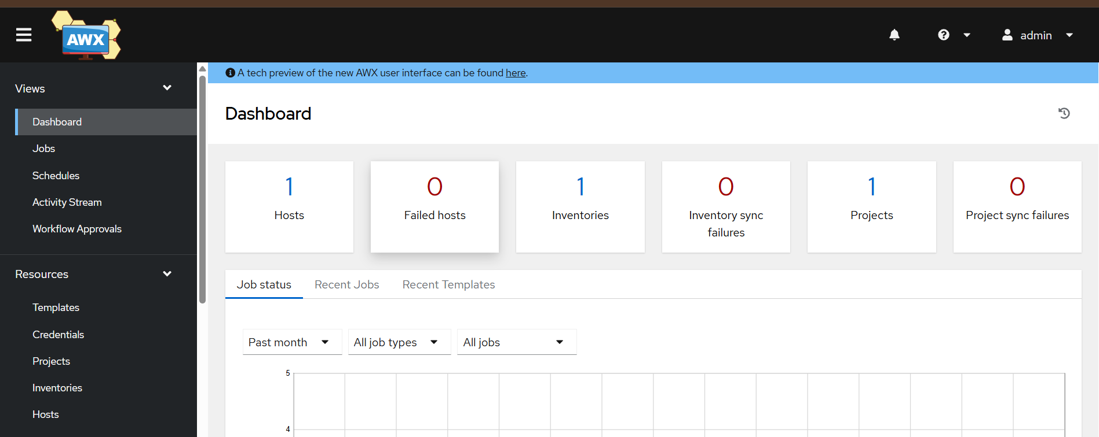
Step 1: Create an Inventory in AWX
- Open your AWX web page.
- Click Resources → Inventories.
- Click Add → Add inventory.
- Enter these details:
- Name: ansible-workers
- Organization: Default
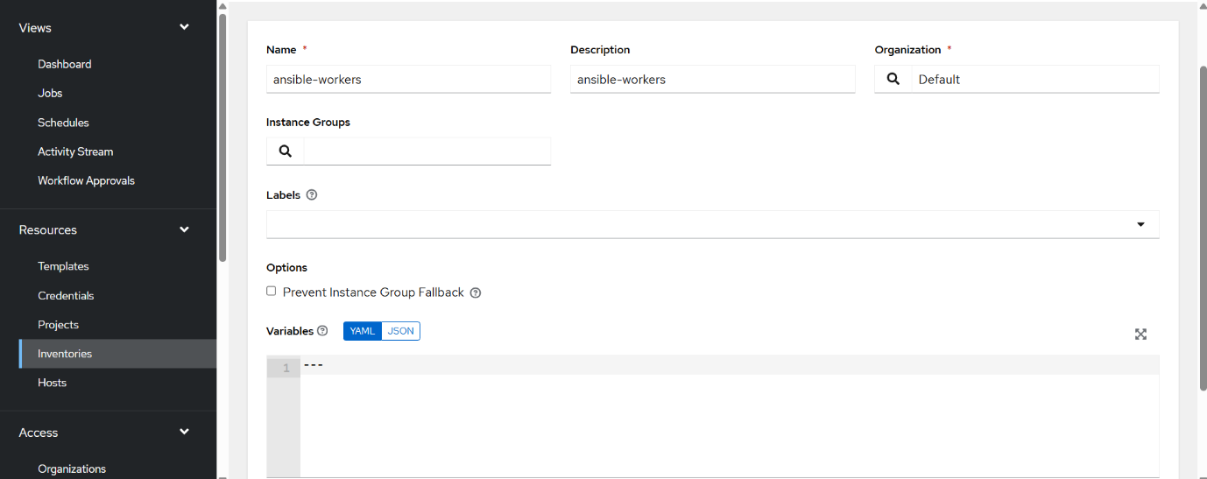
5. Click Save.

Step 2: Add worker1 to your Inventory
- Open Resources → Inventories.
- Click ansible-workers.
- Click the Hosts tab.
- Click Add.
- Enter:
Name
worker1
Variables
ansible_host: 172.31.11.160
ansible_user: ansadm
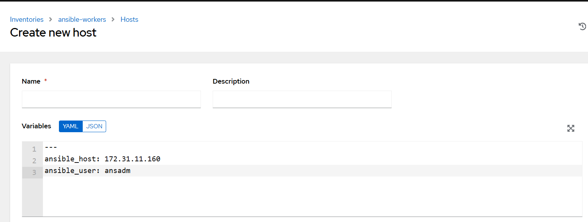
- Click Save.

Step 3: Add worker2
- Open Resources → Inventories → ansible-workers.
- Click Hosts.
- Click Add.
- Enter:
Name
worker2
Variables
ansible_host: 172.31.1.152
ansible_user: ansadm
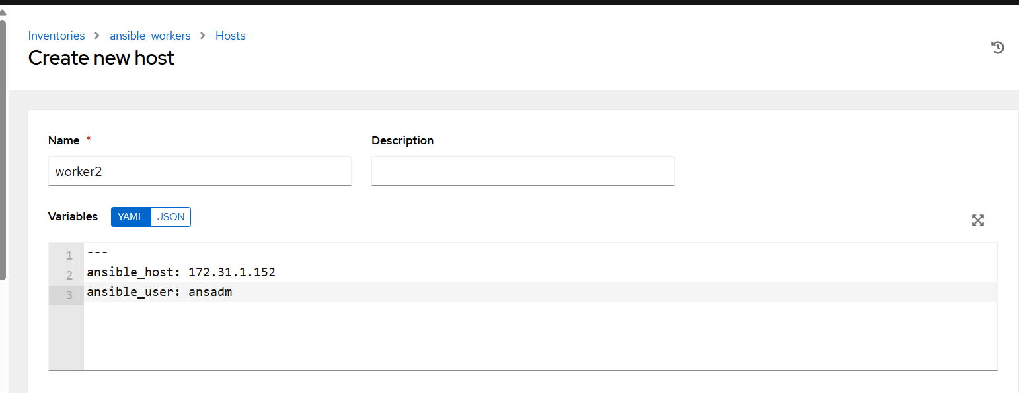
- Click Save.

Step 8: Explore AWX options
our AWX is working at http://44.203.61.171:31680/.
Step 1: Open AWX
- Open the AWX URL in your browser.
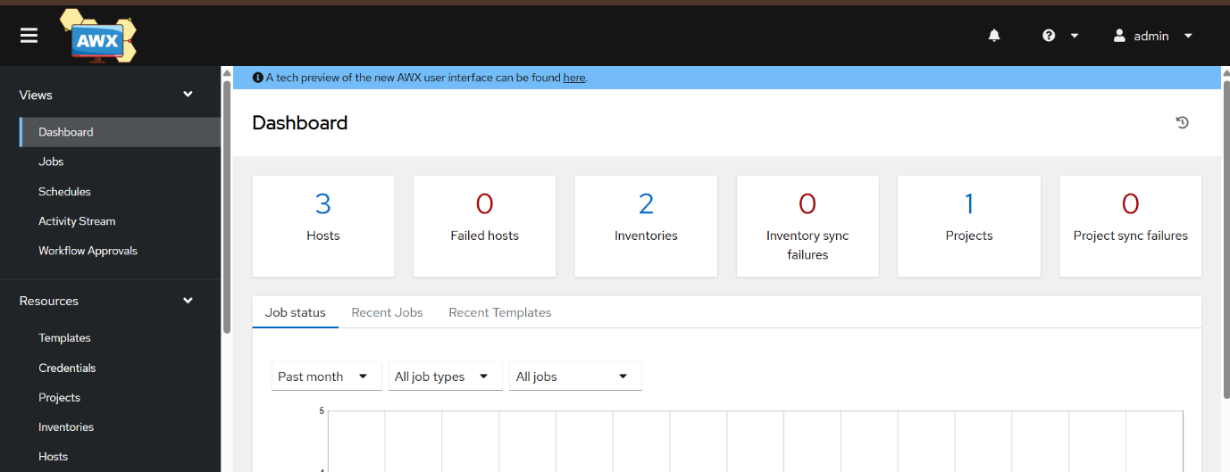
- Log in with username admin and your AWX password.

Step 2: Explore Organizations
- Click Organizations in the left menu.
- View the existing organization.
- Do not change anything yet.
Purpose: Organizes AWX resources and teams.
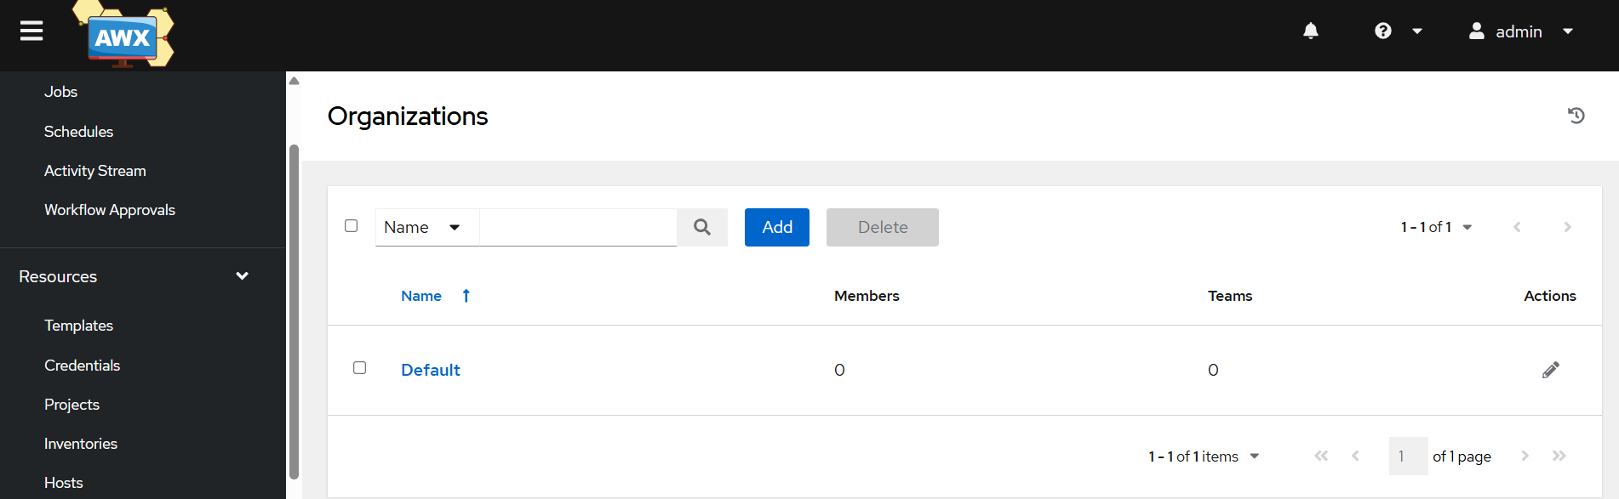
Step 3: Explore Inventories
- Click Inventories.
- Open the existing inventory, if one exists.
- Look for the Hosts section.
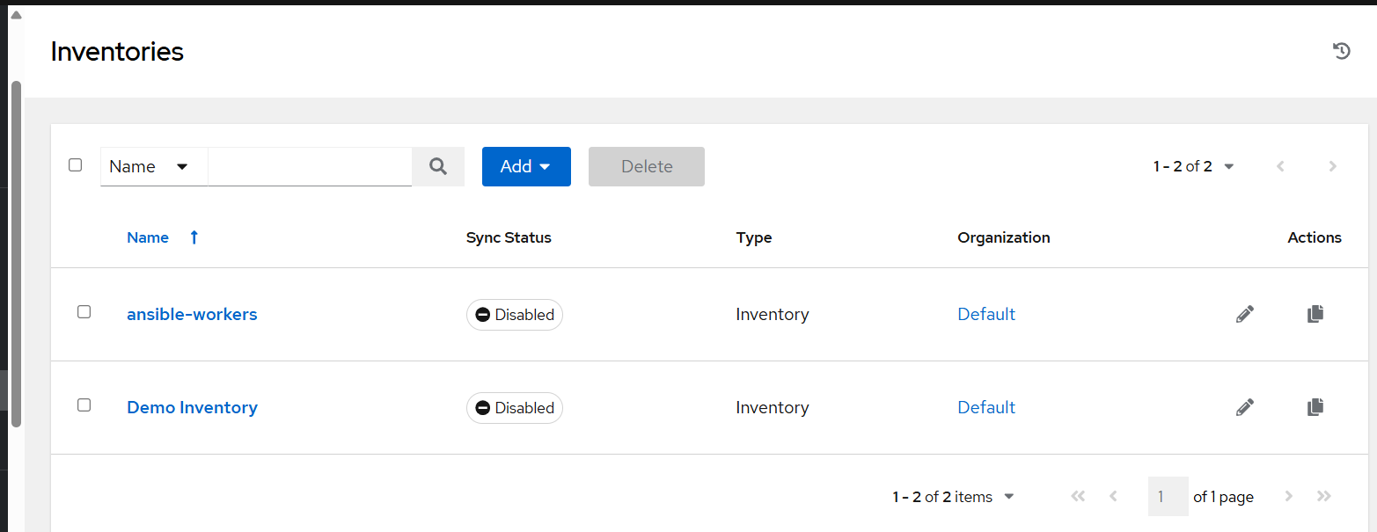
Purpose: Stores the servers on which Ansible playbooks will run.

Step 4: Explore Credentials
- Click Credentials.
- View the available credential types.
Purpose: Stores SSH credentials securely so AWX can connect to your servers.
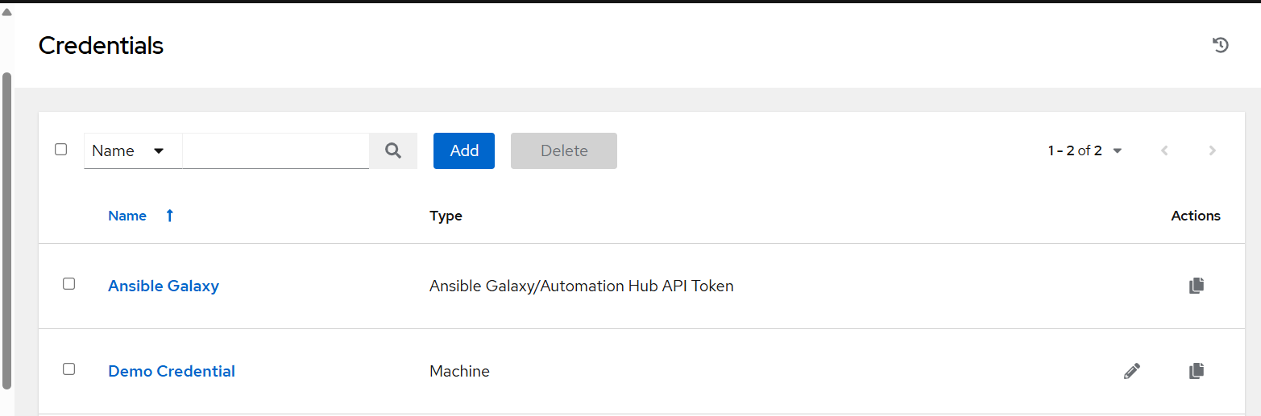
Step 5: Explore Projects
- Click Projects.
- Open any existing project, if available.
Purpose: Connects AWX to a Git repository containing Ansible playbooks.
Step 6: Explore Templates
- Click Templates.
- View the available job templates.
Purpose: Defines which playbook, inventory, and credentials to use when running a job.
Step 7: Explore Jobs
- Click Jobs.
- View previous jobs, if any.
Purpose: Shows job status, output, and errors.
Step 8: Explore Schedules
- Click Schedules.
- View the available schedules.
Purpose: Runs automation at scheduled times.

Step 9: Explore Workflow Templates
- Click Workflow Templates.
- View the available workflows.
Purpose: Connects multiple automation jobs into one workflow.
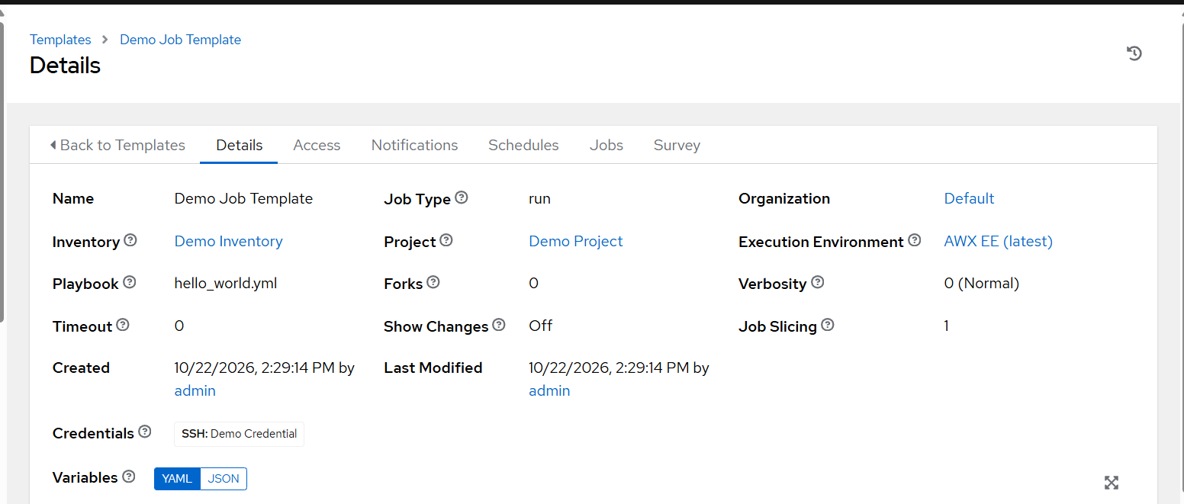

Step 9: Test your Ansible playbook in AWX
We will connect your existing lamp.yml playbook and roles/ directory to AWX, then run it against your EC2 worker hosts.
We’ll do this one step at a time. First, make sure lamp.yml and the roles/ directory are pushed to your Git repository. AWX will download the playbook from Git.
Step 9.1: Locate your LAMP project
On your k8s-master, run:
find /home/ubuntu -type f -name "lamp.yml" 2>/dev/null
Then check whether the project directory exists:
ls -la /home/ubuntu/lamp-role-lab
Your project should contain:
lamp-role-lab/
├── lamp.yml
└── roles/
├── apache/
├── mariadb/
└── php/
Create a Project in AWX
- Open your AWX browser.
- Click Projects.
- Click Add.
- Enter these details:
- Name: LAMP-Project
- Organization: Select Default
- Source Control Type: Git
- Source Control URL: https://github.com/satishcloud00/ansible_test.git
- Source Control Branch/Tag: main
- SCM Update Options: Leave defaults.
- Click Save.
- Open the project and wait for its sync to finish.
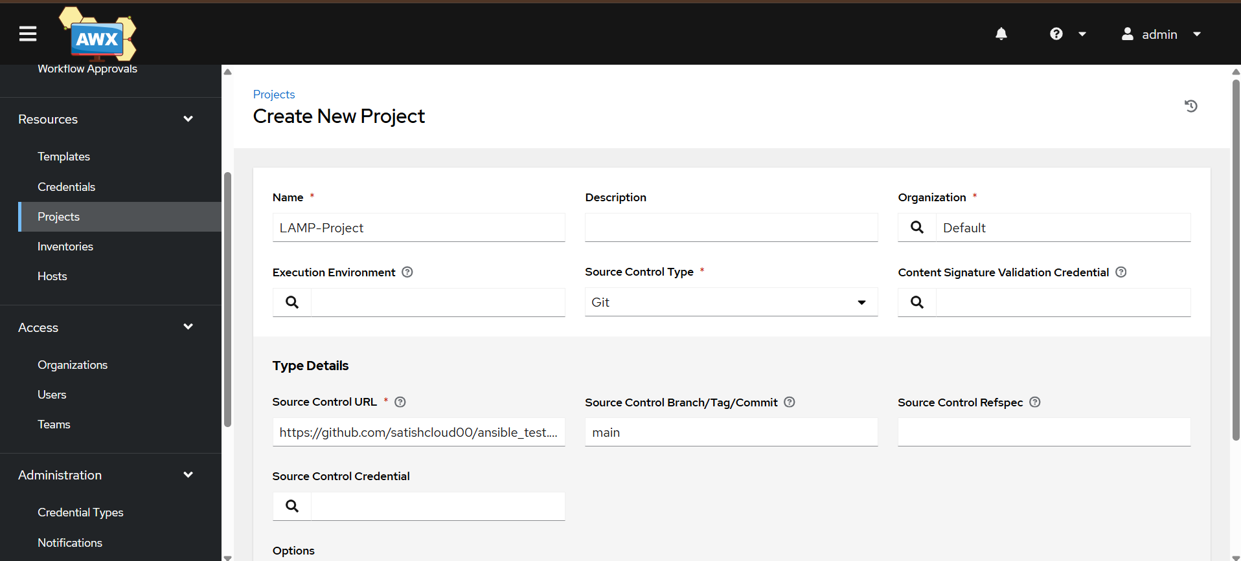

Create an Inventory
- In AWX, click Inventories.
- Click Add → Add inventory.
- Enter:
  - Name: LAMP-Inventory
  - Organization: Default
- Click Save.
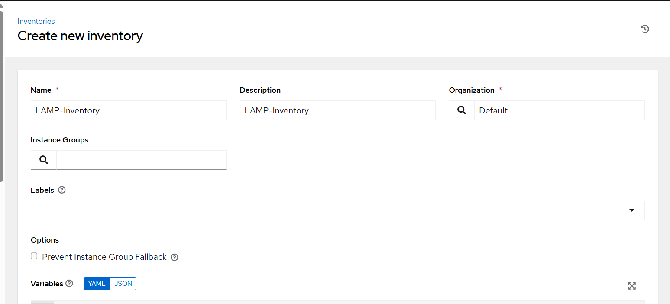
- Open LAMP-Inventory.
- Go to Hosts and click Add.
For the host, enter:
- Name: worker1
- Variables: We'll add the EC2 private IP in the next step.
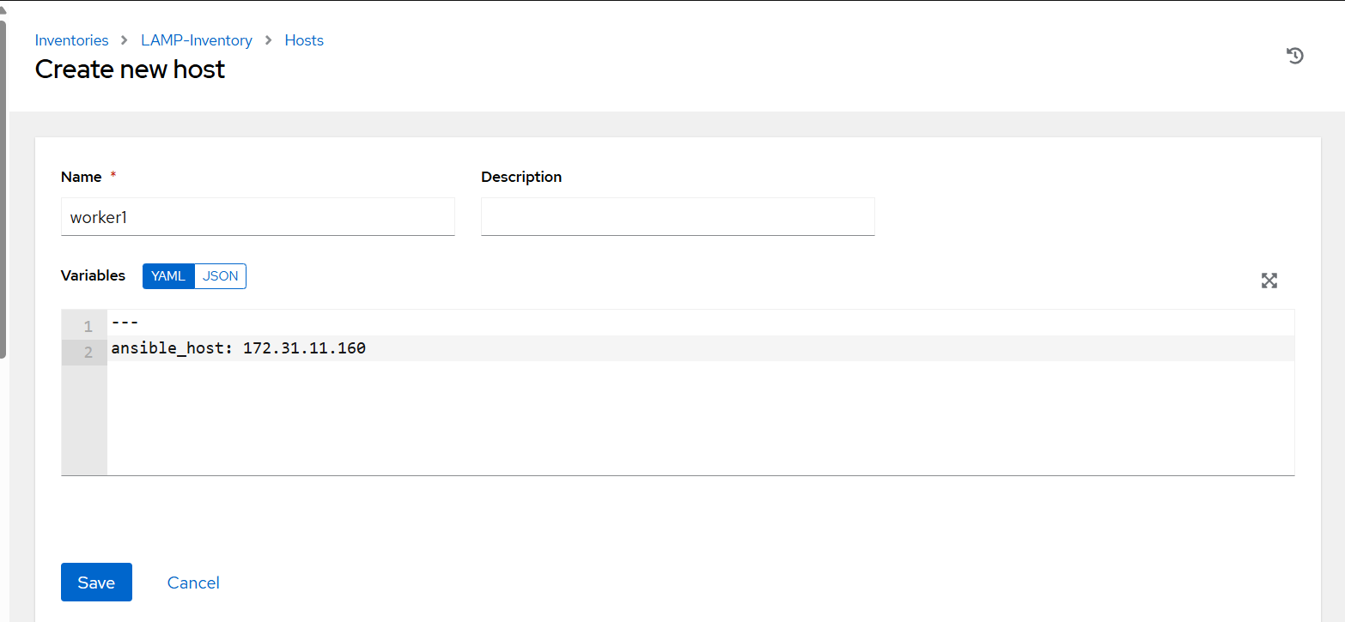
Click Save.

Important: Your repository currently contains lamp.yml at the root, so AWX can locate it there. The roles/ directory is currently empty; we'll address that before running the playbook if it needs roles.
Create an SSH Machine Credential
This allows AWX to connect to worker1 (172.31.11.160) using SSH.
- In AWX, click Credentials.
- Click Add.
- Enter:
- Name: LAMP-SSH-Credential
- Organization: Default
- Credential Type: Machine
- Username: ubuntu
- Find SSH Private Key and paste the private key that can connect to 172.31.11.160 (the matching key for that EC2 instance).
- Leave other settings at their defaults.
- Click Save.
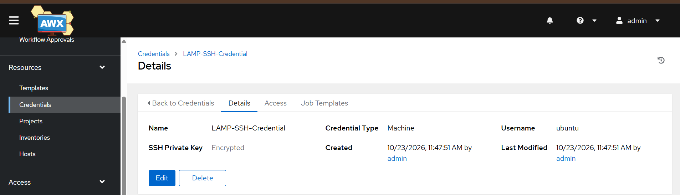
Create a Job Template
- In AWX, click Templates.
- Click Add → Add job template.
- Enter these details:
Field | Value
Name | LAMP-Job-Template
Job Type | Run
Inventory | LAMP-Inventory
Project | LAMP-Project
Playbook | lamp.yml
Credentials | LAMP-SSH-Credential
4. Click Save. 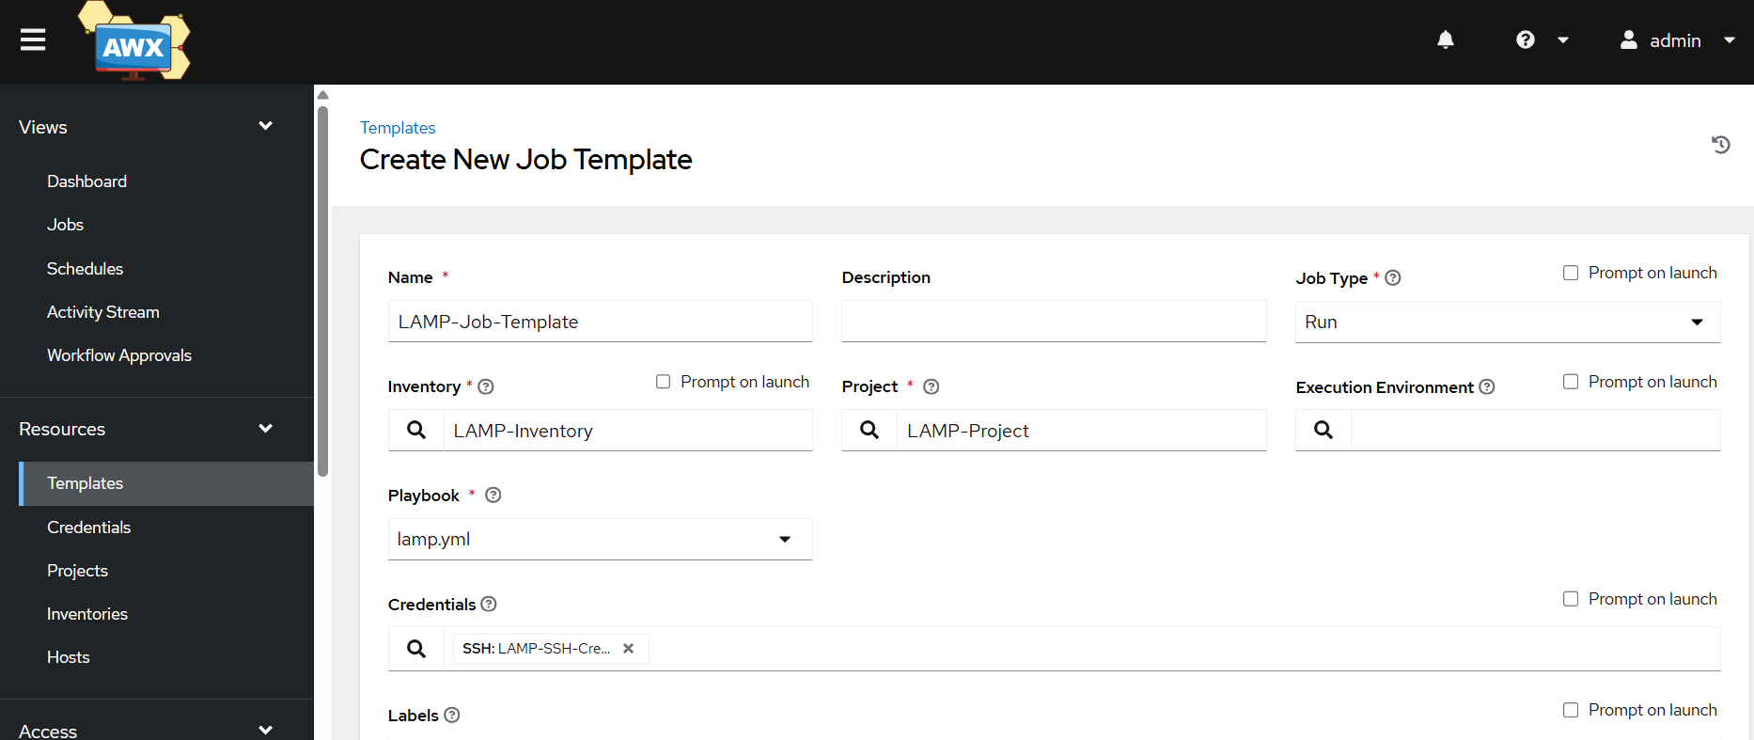
Important: Your current playbook uses Ubuntu package names, so the target worker must run Ubuntu.
Launch your LAMP Job
- In AWX, click Templates.
- Find LAMP-Job-Template.
- Click the Launch 🚀 button.
- Wait for the job to finish.
- Click the job to view its output.
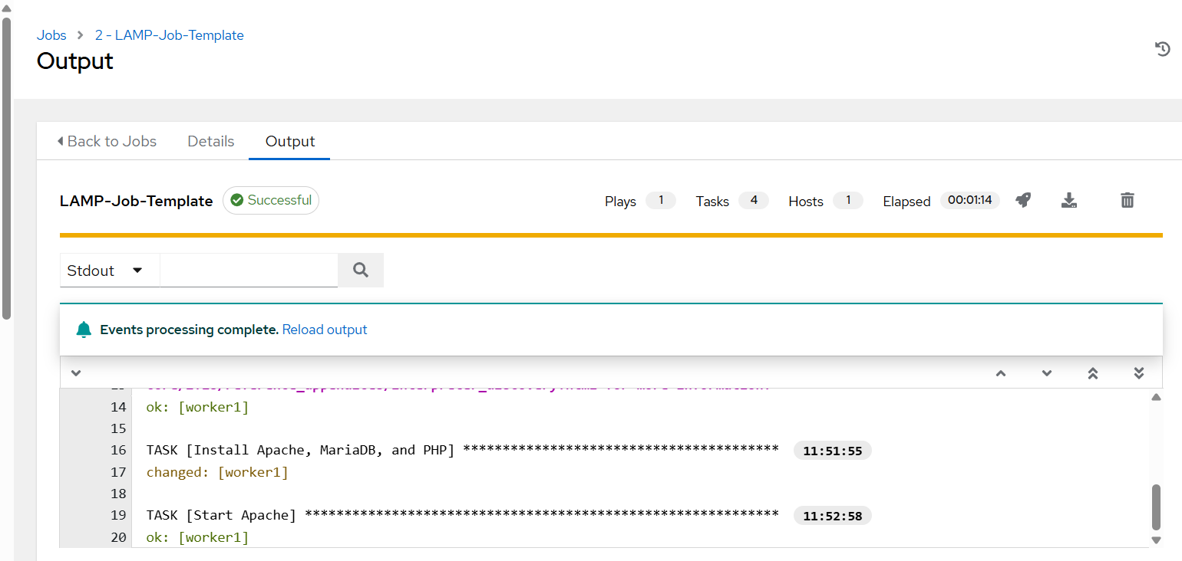

- Connected AWX to your GitHub repository.
- Configured an inventory and SSH credential.
- Created and launched a Job Template.
- Ran the LAMP playbook against one worker.

Final verification
systemctl status apache2
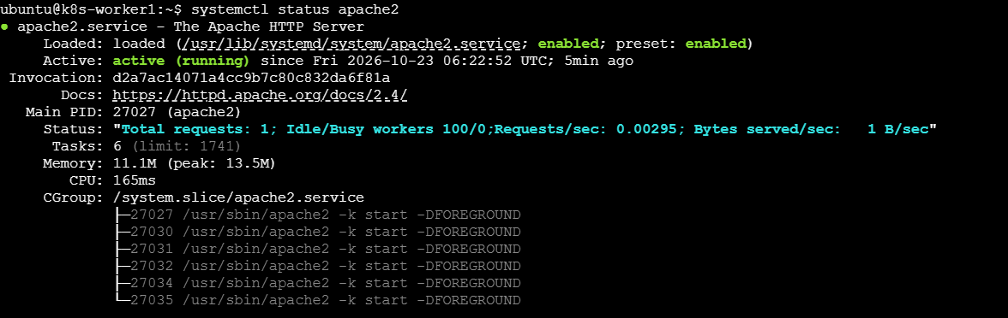

Important: Step 4 requires the AWX Operator to be installed first. AWX also needs sufficient cluster resources and persistent storage; the minimal YAML above is a starting configuration, not a guarantee of a successful deployment.

